**Successful supply chain training**

The Sustainable Artisanal Mining (SAM) Project organized a training on “The gold supply chain and its importance”. The training involved artisanal miners and representatives from Mongol Bank, the Precious Metal and Assay Department, and the Artisanal and Small-Scale Miners’ National Federation. During the training, participants discussed artisanal miners’ contributions to the gold supply chain within a macroeconomic framework and presented supply chain situations, challenges and solutions, operational mechanisms and network policy issues.

In 2016, individual miners supplied 10.4 tons of gold to Mongol Bank, the equivalent of USD $343 million (MNT 860 billion). In addition, MNT 21 billion in royalty payments - the fee of mineral resources - was accumulated in the state budget. According to Article 46.3 of the Law on Mineral Resources, Mongol Bank’s price for precious metals and gems is in line with the international market rate (minus a 2.5 percent of royalty fee). Special license-holders can export precious metals and gems through Mongol Bank as stipulated in Article 46.4 of the law.

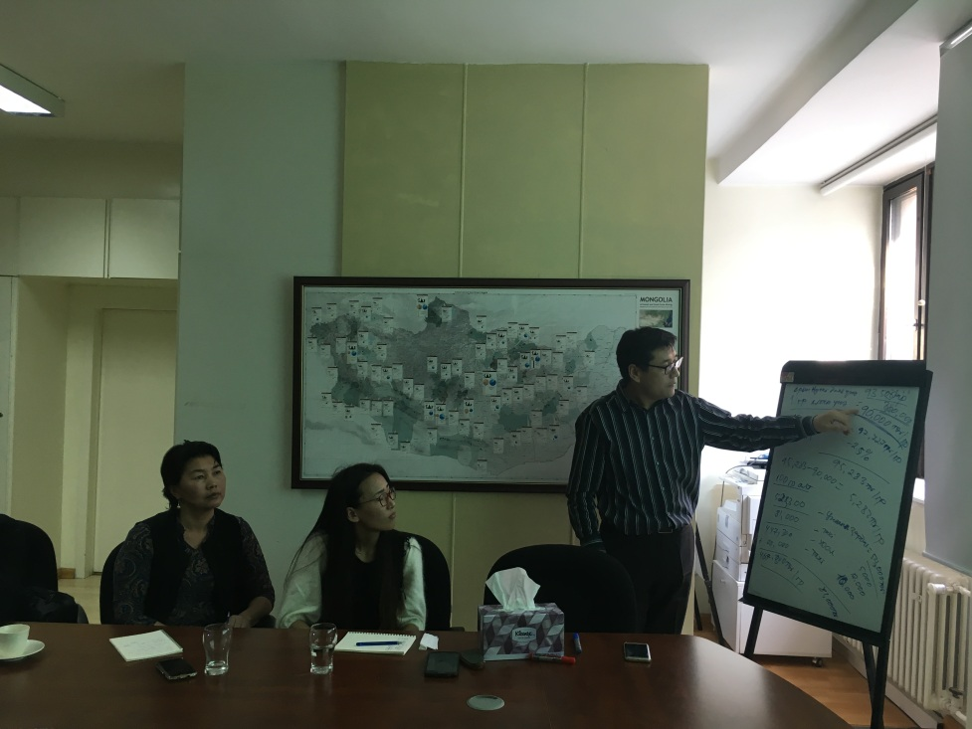

Artisanal miners have their gold and gold particles made into gold bars at the Precious Metal and Assay Department’s melt shop. Serial numbers and the identification of the Precious Metal and Assay Department are imprinted on the gold bars. After they’re melted, documentation and waste remnants from the gold bars are returned to the miners. The documents state the weight of gold before and after melting, the weight of the waste and the amount of diet from melting evaporation. In order to examine the gold bars, a 3-5g sample is taken by drilling into two sides of the gold bar and separated into two to three pieces weighing 250g. Analytic scales are then used to weigh the samples.

In addition to the gold standard, the silver standard is separately identified during the examination of the gold bar. At the end of the examination, payment is made and documents certifying gold and silver standards are given to the miner as well as the gold bars, which are sealed in bags. Those bars can be sold to Mongol Bank or other commercial banks. Mongol Bank only receives gold bars that have been examined by the Precious Metal and Assay Department. There is no maximum or minimum limit of gold bars that can be sold to Mongol Bank.

# PATH TO SUCCESS PAVED BY ASM development

After graduating from high school, B. Tsog-Yuren yearned to continue her education but she had to herd livestock while she took care of her grandparents in the countryside. Tsog-Yuren is now the leader of “Delgereh” ASM partnership and a member of the “Eh oron hamtiin huch” NGO (The Nation and Collective Power) in Airag soum, Dornogovi aimag. She married a man from her hometown in 2008 and now has three children.

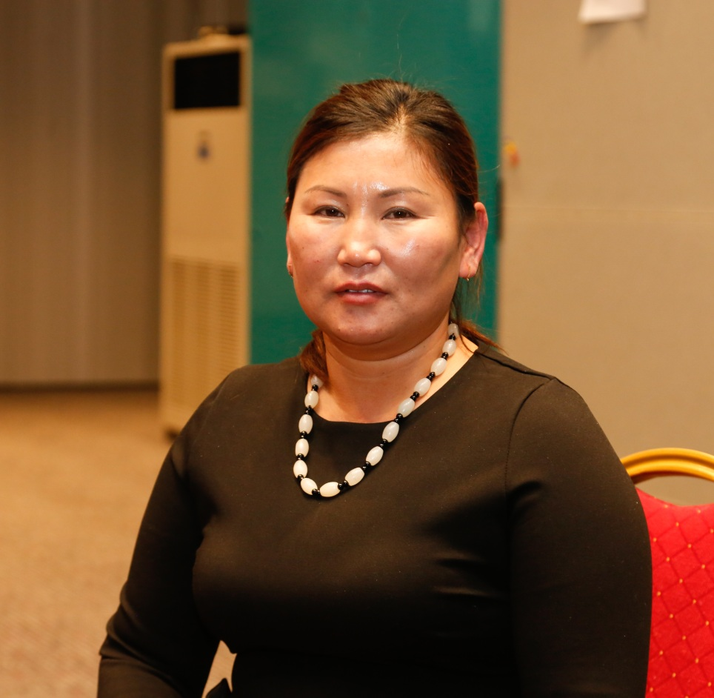

Although they made a living from herding, the arrival of their children prompted a need for more income. At that time, a spar deposit was discovered close to their winter camp, and it soon drew a number of illegal ASM miners. Tsog-Yuren and her husband joined them.

When it came time for her children to attend school, they settled their livestock on another family’s farm, bought a home and a car with the money they made mining spar and settled down in the soum centre. In 2006 a dzud struck and they lost all their livestock and found themselves unemployed. With few options, they resumed spar mining in 2008.

Based on their previous experiences, they bought a compressor to ease their workload, which they were able to profit from by renting it to other miners. However, Tsog-Yuren said, “We lost a lot due to our lack of financial knowledge and wisdom in spending money properly”.

Mining spar is a hard work, and there were no government agencies or organisations working to protect artisanal miners’ rights. In addition, the negative public perception of ASM resulted in many miners being sent away and forced to hide from others. Then a Chinese national killed an artisanal miner, which shocked Mongolians and left many thinking “How can we live when there is no guarantee in our lives?” and “To whom should we address our concerns?” Realising that they must fight for their own rights, they united and formed the “Eh oron hamtiin huch” NGO with L. Lhagva, who worked with them.

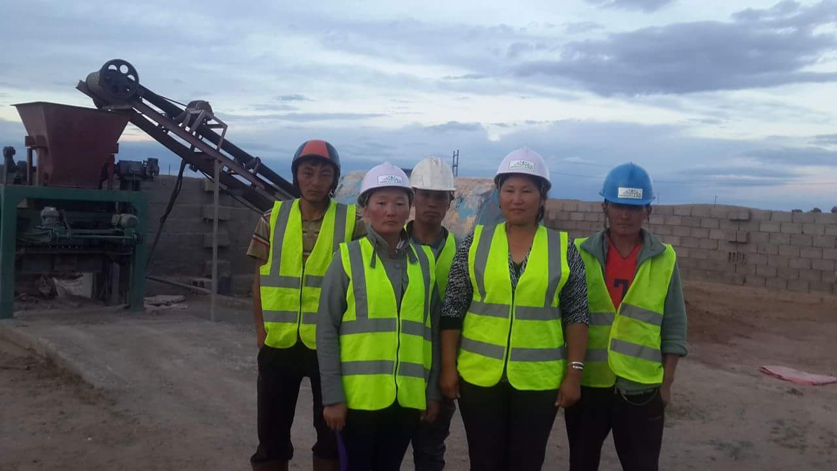

They were looking for ways to make improvements when they learned about SDC’s SAM Project, which upholds the rights of ASM miners throughout the country.

Tsog-Yuren said most beneficial were trainings on human rights and project development and implementation, which she continues to benefit from. The human rights trainings made her aware of miners’ responsibilities and their rights, and she began paying all the required government taxes. When other members were also enrolled in health and social insurance, they received a Best Taxpayer certificate. It also enabled them to ensure their health was protected and had better access to social welfare services.

The project development and implementation trainings helped them to make significant changes. Based on the knowledge they gained, they developed and implemented a “block plant” after taking out a loan through the Soum Development Fund. They also expanded their operations and prepared a business plan for the implementation of a coloured panels project to secure a SAM Project grant.

In addition to her role as NGO leader, Tsog-Yuren contributes to employment promotion in the soum through the creation of jobs such as running a small welding-apparatus shop, and has collaborated with five other women in making homemade buuz through a Soum Development Fund loan. She also provides regular employment for six people and has enabled five members to buy their own homes and three members to buy vehicles. She also hired a single mother with six children as a cook and guard for the NGO, providing her with a regular income and supplying her with firewood and electricity.

In the early years, the authorities didn’t understand and disliked the spar miners, and they were not supported by the local community. Now, however, with SAM Project support in improving the legal framework and the conducting of trainings and activities, attitudes have markedly improved.

Tsog-Yuren became a member of Bagh 1’s Citizens’ Representative Khural and the head of the association of “Wealth Producers”. As a trusted figure, she seeks opportunities for artisanal miners to undertake alternative forms of employment and disseminates ASM information among the local community. She has also shared some of her successful initiatives with the local government, such as connecting businesses and individuals with clients and suppliers, financed through the Soum Development Fund.

As a result of the strong relationship with the local government, she said “We have received an order to build a pedestrian sidewalk and are very busy despite recently establishing the plant”. She shared her plan to open a tyre-repair shop and furniture factory based on the block plant. She said the SAM Project trainings taught them the importance of working with “defined goals and plans as a means to achieve”.

With support from the SAM Project, Tsog-Yuren has become a role model for women and has achieved much through her hard work and vision. As her success demonstrates, development projects can make changes for individuals, households and society by expanding growth and opportunities.

**Trip to Dundgovi aimag and Khuld soum**

The SAM Project’s leadership team conducted a two-day trip to Dundgobi aimag and Khuld soum, where they met with governors, government officials and miners. The aimag and soum governments are supportive of ASM operations. Based on Government Regulation #308, the Dundgobi Aimag Khural approved a regulation for aimag ASM operations. The Khuld soum governor also entered into contracts with two ASM partnerships that allow 252 local miners to work on the “Tuimert Tsagaan” fluorite site, about 10km from the soum centre. The contracted miners pay taxes and health and social insurance. The soum government provides a certificate of origin for purchasing companies to export fluorite to China and Russia.

Khuld soum has high-quality fluorite, of a 85-92 percent grade. Fifty percent of Khuld soum’s general service budget now comes from ASM operations. The soum governor said the miners’ income and their livelihoods had improved through ASM organisation and formalisation, and many retired locals were also now working as miners.

The team also visited a small sewing workshop in the Khuld soum centre that is run by five female members of the “Takhilgat Lusiin Bulag” ASM NGO who received a small SAM Project grant through a World Vision program in 2016. Members also manage a savings group that is particularly beneficial for lower-income miners.

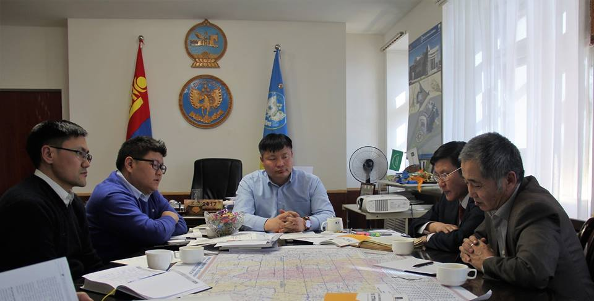

The main issue in fluorite mining soums is the selection of purchasing companies. Dundgobi aimag’s regulation for ASM operations within the aimag was largely aimed at coordinating the purchase of fluorite from miners. It selected four local companies to purchase fluorite from miners in Khuld soum through tripartite contacts. Large equipment is required to extract fluorite from hillsides, which is then transported to the site for miners to collect and sort. Thanks to the tripartite agreements between the soum governor, ASM partnerships and fluorite purchasing companies, there is an active mining and purchasing operation on site.

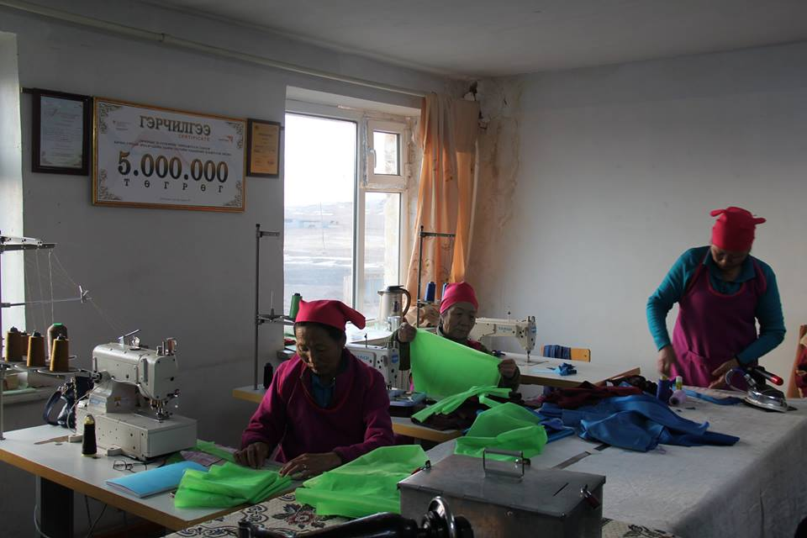

However, the aimag governor said more training on ASM organisation, formalisation and occupational safety and health were needed for miners. A task force supporting and coordinating ASM operations was established in Khuld soum that is headed by the vice-governor.